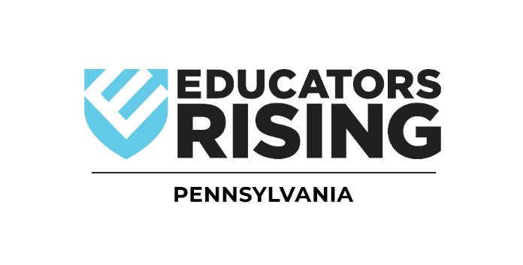

Pennsylvania
Educators Rising
Spring Conference
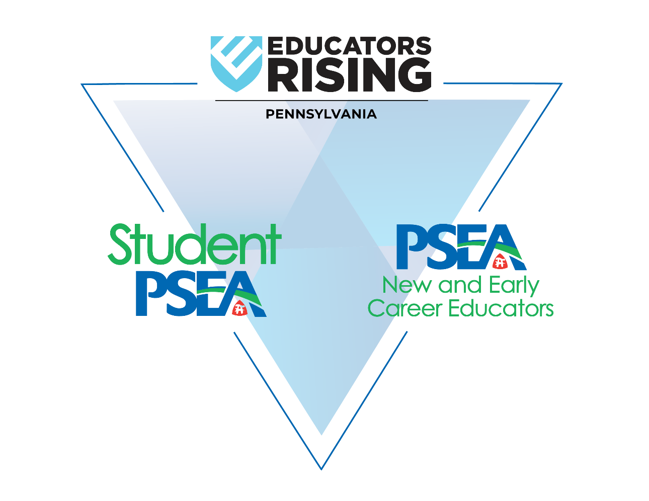

MARCH 13, 2026
8:00 am - 4:00 pm

The Nittany Lion Inn & Penn State Campus
State College, PA

AGENDA
Registration & Event Check-In

Time | Event | Location
7:45 AM – 8:30 AM | Competitors Check-In
8:00 AM – 10:00 AM | Event Check-In for All

Competitions

Time | Event | Location
8:00 AM – 10:00 AM | Creative Lecture/TED Talk (Individual) | Room
8:00 AM – 10:00 AM | Educators Rising Moment (Individual) | Room
8:00 AM – 10:00 AM | Public Speaking (Individual) | Room
8:00 AM – 10:00 AM | Public Service Announcement (Team) | Room

Detailed Agenda

Time | Event | Location
10:15 AM – 11:00 AM | Welcome & Opening Ceremony
11:10 AM – 12:10 PM | Breakout Session I | *See Sessions Page 4
11:10 AM – 12:10 PM | Teacher Leader Session | Room
12:20 PM – 1:10 PM | Lunch
1:10 PM – 1:50 PM | Keynote: Madeline Loring, 2026 PA ToY
2:00 PM – 3:00 PM | Breakout Session II | *See Sessions Page 4
2:00 PM – 3:00 PM | Teacher Leader Session | Room
3:15 PM – 4:00 PM | Closing & Awards Ceremony

SESSIONS

Keynote: Teach With Joy. Teach With Purpose. Teach Like You Mean It.
Madeline Loring, 2026 PA Teacher of the Year
Location:

Breakout Session I (11:10 am-12:10 pm):

- What is it Like to be in a College Teacher Prep Program?, Student PSEA Panel
Location: Room

- SLAY! Sustainable Learning, Authentic You, Madeline Loring, 2026 PA Teacher of the Year
Location: Room

- Lessons from Nerd Fandom, Ryan Hardesty, 2023 PA ToY
Location: Room

- From Students to Teachers: Insights from Penn State Ed. Students, Ashton DeMorat & Hannah Delveccio, Moderated by Krishawna Goins
Location: Room

- Taste the Tech: Explore Tools Future Teachers Will Love, Dr. Samantha Fecich
Location: Room

Breakout Session II (2:00 pm – 3:00 pm):

- What is it Like to be in a College Teacher Prep Program?, Student PSEA Panel
Location: Room

- PA Teacher of the Year Panel, Ryan Hardesty, & Madeline Loring
Location: Room

- From Students to Teachers: Insights from Penn State Ed. Students, Ashton DeMorat & Hannah Delveccio, Moderated by Amanda Smith
Location: Room

- So, You Wanna Be an Ed Major? A Guide to Thriving as a Future Teacher, Dr. Samantha Fecich
Location: Room

- The First-Gen Survival Guide: A Guide for First-Generation Students Preparing for College, Kaysey Beury
Location: Room
SPEAKERS
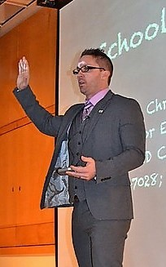
Dr. Christopher M. Clayton Sr., NBCT, Ph.D
Educators Rising PA State Coordinator, PSEA Director of Education Services for the Educator Profession & Pipeline
Dr. Christopher M. Clayton is the Director of Education Services for the Educator Pipeline and Profession for the Pennsylvania State Education Association. In this role with PSEA, he is responsible for providing support to over 178,000 educator members on issues involving best practices and research in teaching and learning, directs the Student PSEA Aspiring Educator (college student) Program, serves as the State Coordinator for Educators Rising (high school student) Pennsylvania Program and coordinates the PSEA Early New & Career Educator Platform.
He earned a Ph.D. in Language and Literacy Education and an Ed. S. Degree in Education Leadership, Administration, and Policy at The University of Georgia along with a Master's Degree in Curriculum & Instruction from Regis University in Denver, CO. He is a National Board-Certified Teacher (2008, renewed in 2018) who was named the Washington Puyallup Valley Teacher of the Year in 2011 prior to starting with PSEA where he served as a high school English and International Baccalaureate Theory of Knowledge teacher and coach for over ten years in Southern California and Washington state before becoming a district administrator and Director of Curriculum & Instruction in a large metro-Atlanta school district with 138 schools and over 100,000 students. He moved to Hershey to begin his role with PSEA in 2014 and happily resides there with his wife, two daughters, son, and granddaughter.

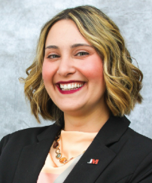
Madeline Loring, 2026 PA Teacher of the Year
Madeline Loring is the 2026 Pennsylvania Teacher of the Year and a dedicated educator with 14 years of experience in public education. Her career includes two years in special education, nine years in kindergarten, and she is currently in her third year as a fourth-grade math teacher at Jefferson-Morgan Elementary School, where she brings learning to life through intentional, student-centered instruction.
Madeline is a proud wife to her husband, Wes, and mother to three daughters-Evee (7), Ellie (4), and Edee (2). She and her family live on their fifth-generation family farm in the same school district she proudly serves, strengthening her deep connection . to the community and families she teaches.
She is actively involved in her community, serving on various local boards and as a CCD teacher at St. Matthias Parish, leading with authenticity, compassion, and a belief in the power of relationships.
At the heart of Madeline’s work is a guiding belief: “Education is not a one-size-fits-all. I strive to create unique, engaging, and meaningful learning experiences that honor each child’s potential, rooted in connection, community, and heart, because every student deserves to feel seen, supported, and inspired to thrive.”
As the Pennsylvania Teacher of the Year, Madeline is committed to advancing statewide efforts to recruit and retain future educators. She is especially passionate about supporting student teachers-encouraging them to be unapologetically themselves, bring joy into their classrooms, and never forget the spark that ignited their calling to teach. When educators teach with heart, lead with joy, and show up as their authentic selves, students don’t just learn; they thrive.

Ryan Hardesty, 2023 PA Teacher of the Year
Mr. Ryan Hardesty, the 2023-2024 Pennsylvania Teacher of the Year, teaches middle school social studies in the Blackhawk School District. Through engaging opportunities, he reassuringly challenges his students to set personal goals and reach their highest potential. He works tirelessly to build connections with his students to be able to encourage them on their educational journey.


Kaysey Beury, Assistant Director of Student Success at Pennsylvania College of Technology
Kaysey Beury serves as Assistant Director of Student Success in the Michael J. Hudock, Sr. Center for Academic Excellence at Pennsylvania College of Technology. She supports students in overcoming academic challenges and leads programming for first-generation students. Kaysey also co-advises the Lambda Xi chapter of Alpha Alpha Alpha, the National Honor Society for First-Generation College Students. Before joining Penn College, she taught middle and high school English in Virginia and Pennsylvania. As a first-generation college graduate, Kaysey is committed to empowering students to achieve their goals and thrive in higher education.

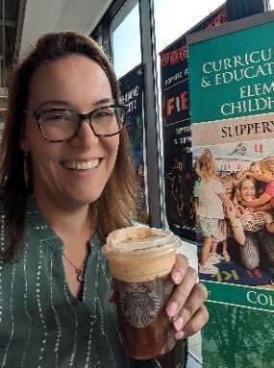
Dr. Samantha Fecich
Samantha Fecich, Ph.D., is an Assistant Professor of Education at Slippery Rock University, author, and host of the EduMagic podcast. Her work centers on empowering preservice and new teachers through innovative, tech-integrated instructional practices. Dr. Fecich’s research interests include educational technology integration, special education, Universal Design for Learning (UDL), and effective strategies in teacher preparation.
She is the author of EduMagic: A Guide for Preservice Teachers, Crush It from the Start: 50 Tips for New Teachers, and EduMagic Shine On. Through her writing, speaking, and mentoring, she supports early-career educators in building confidence and competence as they transition into the classroom.
Learn more about her work at www.sfecich.com or connect with her on Instagram at @sfecich.


Hannah Delveccio, Student PSEA Central Region President
I am a Senior at Penn State University Park, majoring in Middle Level Social Studies Education with a certificate to teach English as a Second Language. I joined SPSEA my freshman year of college and served as the Central Region Vice President as a junior. I currently serve as the Central Region President and Vice President for Penn State’s SPSEA chapter.

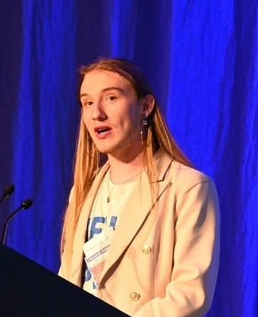
Gavin Mitsdarfer, Student PSEA PACE Director
Gavin Mitsdarfer is a senior education student at Pennsylvania Western University, Edinboro, with a dual concentration in Secondary English Language Arts and Special Education PreK-12 with a minor in Literature and Culture. Gavin currently serves as the PSEA State Political Action Committee for Education Director and as the NEA Aspiring Educators Caucus Lead Director, as well as on the NEA Aspiring Educators Advisory Committee. Gavin represents PennWest in PASSHE on the UPrepared Summit, looking to address the teacher shortage, and was recognized as a PASSHE Keeper of the Flame for their work on addressing teacher diversity through the Student Teacher Support Program. Gavin wrote their undergraduate thesis on the . inclusion of multicultural literature and presented the research at the PASSHE Frederick Douglas Institute Research and Creative Arts Conference.


Bella Liberto, Student PSEA Vice-President
My name is Bella Liberto. I am a senior at West Chester University, where I am studying Early Childhood Education and have minors in Special Education and Literacy. In the spring, I will be student teaching 4th-grade students in Media, Delaware County! I have been a part of Student PSEA for all 4 years of college. Being on executive boards at the chapter, region, and state level! My favorite thing about Student PSEA is the connections I have made through networking and with my fellow pre-service teachers. I have also learned through professional development opportunities that have prepared me for what is to come. I am grateful for Student PSEA and all I have learned and grown from this experience.


Ashton DeMorat, Student PSEA President
Ashton attends Pennsylvania State University. He is the 2025-2026 Student PSEA President.

STUDENT OFFICERS
The student officers of this Association shall consist of a President, Vice-President, Recording Secretary, and Public Relations Secretary. The term of office for the officers shall be one year or until their successors are duly qualified. Incumbents are eligible to seek reelection to the same office for one additional year.
The President:
- Shall be the Chief Executive Officer of the Association;
- Shall represent student members of the Association as public spokesperson on matters of policy or assign responsibility for such representation;
- Shall aid in preparing the agenda and help preside at all meetings of the Association;
- Shall appoint the chairpersons of such committees as are deemed necessary and shall have the authority to appoint members to those committees or delegate such authority to the chair;
- Shall serve as Member Ex Officio on all committees;
- Shall serve as a delegate to the House of Delegates and chair its meetings;
- Shall have a working knowledge of the parliamentary procedure.
The Vice-President:
- Shall preside in the temporary absence of the President;
- Shall be an assistant to the President;
- Shall serve as Member Ex Officio on all committees;
- Shall perform other duties as delegated by the President and/or the Executive Committee, which may include serving as chair of one or more committees;
- Shall assume the office of President upon incapacity, death, or resignation of the President;
- Shall have a working knowledge of parliamentary procedure.
The Recording Secretary:
- Shall help maintain records of all chartered Chapters;
- Shall help keep a record of all meetings;
- Shall help keep an up-to-date file on all communications, including the report and minutes of the Executive Committee;
- Shall furnish meeting minutes to members of the Executive Committee in a timely fashion;
- Shall help prepare and maintain the names, phone numbers, email addresses, and physical addresses of: 1. The Teacher Leader responsible for each active Chapter in the state,
- The members of the Executive Committee,
- The chairpersons of all committees appointed by the President, and the officers of all Chapters;
- Shall have a working knowledge of parliamentary procedure.
The Public Relations Secretary:
  - Shall help serve as a contributor to EdRising Pennsylvania promotional and informational content;
  - Shall help maintain up-to-date information about the Association’s growth, events, and activities;
  - Shall help maintain records of all official communications received and carry out correspondence as necessary or as assigned by the President;
  - Shall have a working knowledge of parliamentary procedure.
2025-26 Executive Officers
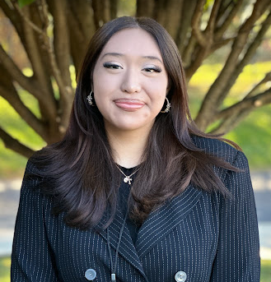
Daniela Luna-Hernandez, President, PA Educators Rising
My name is Daniela Luna-Hernandez, and I'm a senior at Norristown Area High School. I'm also enrolled in the Secondary Education Academy at Central Montco Technical High School, where I've had the opportunity to explore and develop my passion for teaching. This is my third year as a proud member of Educators Rising, and during that time, I've competed and placed in the State Level Competition three times. Teaching is something I genuinely love, and I'm excited to continue learning and preparing for a future where I can make a meaningful impact in education.


Akira Sorrell, Vice-President, PA Educators Rising
My name is Akira Sorrell, and I am a senior at Dallastown Area High School. I plan to major in Secondary Mathematics Education because I believe in the power of positivity, the importance of helping others, and the lasting impact educators can have on students’ lives. I currently serve as president of Educators Rising at Dallastown, where I lead our mission to inspire future educators and foster a sense of unity within our school community. I’m also an active member of several organizations at my school, including the Spanish Club, One Love Club, Interact Club, and Mini-THON. Outside the classroom, I stay active through cheerleading and track and field, and I love being a part of teams that bring energy, dedication, and determination to everything we do. I am honored to work alongside passionate educators across Pennsylvania, and I am beyond excited to create lasting memories as I pursue my future in education!


Trevor Heron, Public Relations Secretary, PA Educators Rising
Trevor Heron is a 12th grader at Phoenixville Area High School. He currently serves as the drum major for the school's marching band and is the social media manager for Phantom Bands. Additionally, he takes tap lessons, participates in theater with a local group, and operates his own photography and videography business. Trevor is enthusiastic about his role as the Public Relations Secretary for PA Educators Rising and is excited to showcase all the amazing things this association does.


Lauren Flick, Recording Secretary, PA Educators Rising
My name is Lauren Flick, and I am the Recording Secretary. I’m part of Educators Rising because I’ve always been interested in making a difference in students’ lives and creating a classroom where everyone feels supported. My goal is to become a high school history teacher because I enjoy learning about the past and how it shapes the world we live in today. In my free time, I love playing soccer with my friends and hanging out with friends and family!
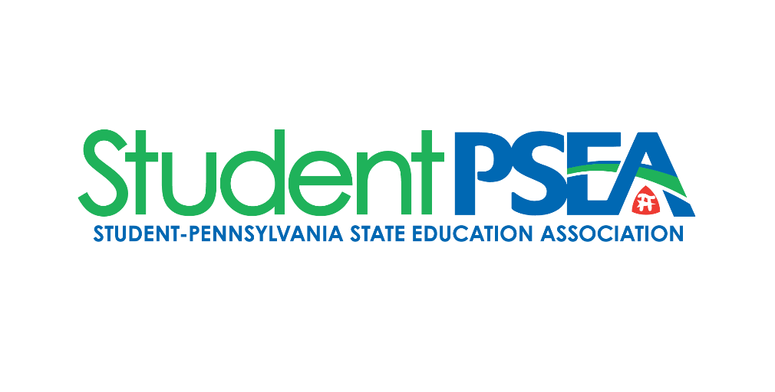



More than 7,000 future educators studying at PA colleges and universities are members of Student PSEA. As part of the next generation of educators, Student PSEA helps members hit the ground running through professional development workshops, service projects, and more.
Join the conversation with other Student PSEA members. You'll hear things like, "Did you know you can join as a multi-year member? It's more cost-effective and guarantees uninterrupted liability coverage!"
Why should you join Student PSEA? Check out the top 10 reasons why by scanning the QRC.


Check out Student PSEA on social media! You can see how Pennsylvania’s Aspiring Educators are involved in their Chapters, communities, and PSEA.


Graduating Class of 2026
The transition to college marks a significant change in your life. It’s a time filled with excitement, new experiences, and challenges. PSEA is here to support you on your journey. If you would like a Student PSEA representative to contact you about getting started with Student PSEA, scan the QRC below and complete the form.

Educators Rising National Conference

Scan the QRC for information regarding the 2026 National Conference.
When: June 20 – 23, 2026
Where: Portland Convention Center, Portland, Oregon
The 2026 theme is Teach with Purpose, Lead with Passion

2025-2026 Pennsylvania Dates to Know
Date | Activity
4/6/2026 | PA Educators Rising 2026-2027 Officer nominations & applications deadline
4/8/2026 | PA Educators Rising 2026-2027 Officer elections open
4/24/2026 | PA Educators Rising 2026-2027 Officer elections deadline
5/1/2026 | PA Educators Rising 2026-2027 Officer candidates announced
4/6/2026 | PA Educators Rising 2026-2027 Officer nominations & applications deadline

Use the QR code on the left below to nominate a student for a PA EdRising officer position. Use the QR code on the right below to apply as a candidate for a PA EdRising officer position.



2025-2026 National Dates to Know
Date | Activity
3/21/2026 | Student officer applicants notified of candidacy status
3/28/2026 | Student officer candidate speech videos submission deadline
4/6/2026 | Early bird registration deadline for the 2026 EdRising National Conference
4/6/2026 | Competition applications deadline – NO EXCEPTIONS
4/6/2026 | Delegate selections deadline – names due to the National Office
4/9/2026 | Competitor list posted for Teacher Leader review
4/9 – 4/16/2026 | Teacher Leaders review the competitor list and add any missing
4/16/2026 | Deadline for competition entry adjustments – NO EXCEPTIONS
5/5/2026 | Educators Rising signing day (local)
5/18/2026 | Competition schedules posted
5/18/2026 | Student officers announced
5/31/2026 | Honor society deadline
6/20 – 6/23/2026 | National Conference dates

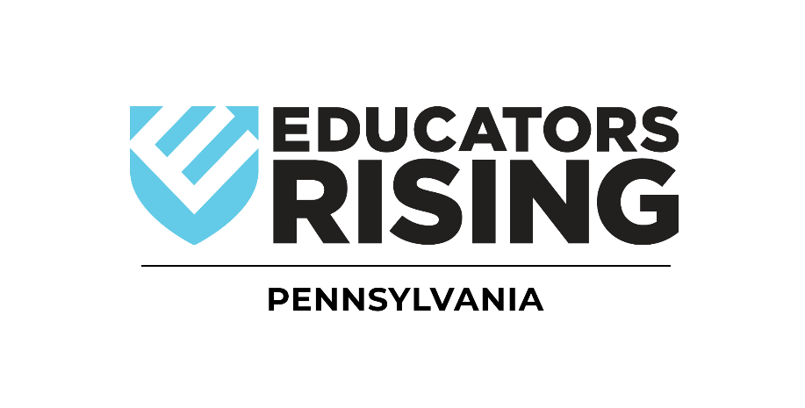

Pennsylvania State Education Association
400 North Third Street
PO Box 1724
Harrisburg, PA 17105-1724

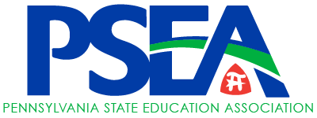
(800) 944-7732

