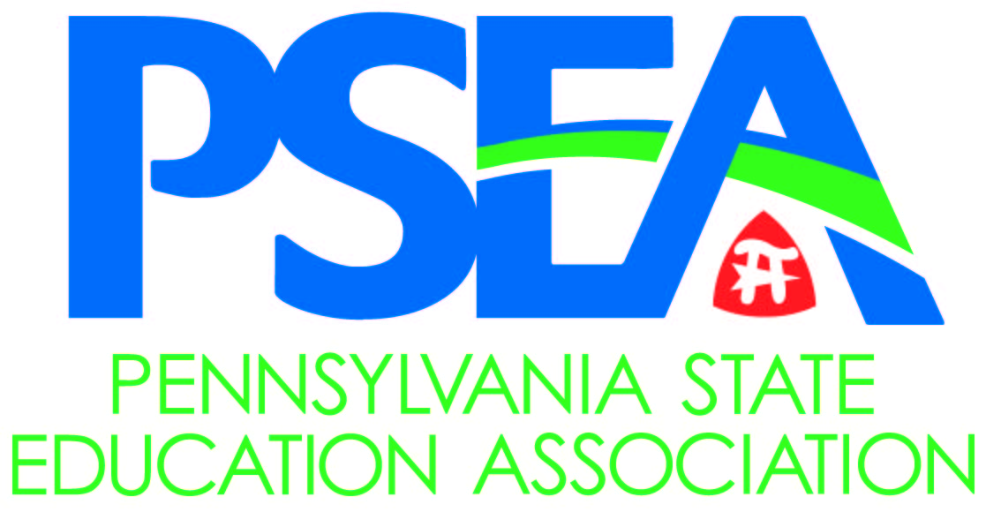

Testimony of the
Pennsylvania State Education Association (PSEA)

Public Hearing Regarding
SB 1230

Presented to the
Senate Education Committee
October 5, 2020

By
Richard Askey
PSEA President

Good morning Chairman Langerholc, Chairman Dinniman, and members of the Senate Education Committee. I am Rich Askey, President of the Pennsylvania State Education Association. Thank you for inviting PSEA to once again share our perspective with you on issues of critical importance to the success of Pennsylvania students.

There is no question that students, families, and educators are feeling the effects of the coronavirus pandemic, including the learning gap created by the necessary closure of schools last spring. The real question now is, what solutions will lawmakers offer to bolster the students and communities that need the most support to help close this gap? PSEA respectfully, but vehemently, disagrees that Senate Bill 1230 should be considered in any way a “solution” for the following reasons:
- First, SB 1230 is a school voucher bill in disguise;
- Second, the bill has a frightening lack of accountability; and,
- Third, there are far better ways to use the $500M proposed in this bill to help all of Pennsylvania’s students, not just the small minority who attend private and religious schools.

SB 1230 is a School Voucher Bill:
Let me be clear, SB 1230 is a school voucher bill.

The “Back on Track” Education Savings Accounts (ESAs), as proposed in Senate Bill 1230 siphons $500 million of precious federal taxpayer monies to unaccountable private educational entities. The bill gives eligible families with school aged children a $1,000 voucher for school related expenses which public schools already provide their students for free, thereby only making private education interests eligible for the funds.

The concept of ESA vouchers is not new. In fact, it was most recently proposed in 2017 by State Senator John DiSanto as Senate Bill 2. Our analysis of Senate Bill 2 at that time showed Sen. DiSanto’s legislation would have siphoned over twelve million public taxpayer dollars – a 17% reduction in state funding - from his largest school district (Harrisburg City) and into the hands of private educational entities. And while SB 1230’s financial impact is less direct and immediate than Senate Bill 2 on a school district like Harrisburg City, the fundamental reality is that SB 1230 establishes a publicly funded program for private education at the cost to taxpayers.

We believe the real goal of this proposal is not to help students get back on track educationally. Rather, it is to establish a foothold for a broader expansion of school vouchers in Pennsylvania. In fact, this bill authorizes ESA vouchers to be around for as long as 15 years.

Senate Bill 1230 and similar proposals are contradictory to the commitment to public education each of you has so clearly demonstrated throughout this past year and for which our 180,000 members are so appreciative. Your swift passage of Act 13 last spring and your support for a full-year of level funding for K-12 and higher education in the FY 20-21 budget clearly demonstrated your recognition that public education is essential for establishing our road to recovery from this pandemic. This is why it is so baffling to me and the members I represent that the General Assembly is even thinking about another version of school vouchers, which have been proven time and again to lack the support of Pennsylvanians.
Pennsylvania has $1.3 billion remaining from the $3.8 billion received in emergency relief funding to support the state’s response to the COVID-19 pandemic under the federal CARES Act. CARES Act money is intended to help public schools with COVID-related expenses, provide compensatory education, and expand broadband for students. Spending hundreds of millions from this fund to help advance the long-term goal of expanding vouchers is completely at odds with the intent of the federal legislation.
SB 1230 and it’s Shocking Lack of Accountability:
As if that isn’t bad enough, this proposal has a shocking lack of accountability. Parents can be reimbursed for a litany of educational expenses (almost all of which are currently provided by public schools for free) regardless of need, and with little to no oversight, transparency, or reporting to evaluate whether the program was successful or not for meeting the intended outcomes. The only required piece of financial accountability is a receipt.
Senators, this is simply not the fiscally responsible way to invest hundreds of millions of dollars. You demand more financial accountability of public schools, as you should. But the same standards should hold true for this proposal. I cannot fathom a less responsible, less effective way to spend half a billion dollars.
What’s more, the bill claims to be something that it is not. Proponents like to say that the ESA vouchers will help public schools too. Public schools do not, should not and cannot charge fees for tuition, tutoring services, instructional materials, textbooks and the like. Public schools are also required to provide all students with disabilities with a free appropriate public education, which includes all educational and related services required to help the student achieve their educational goals. Therefore, public schools cannot accept a voucher as proposed by the legislation.

Better Solutions:

SB 1230 represents a choice between solving a problem in schools where 90% of students attend or advancing an ideological agenda championed by Secretary DeVos in the final weeks of this legislative session. School districts are struggling to address the $1 billion local revenue shortfall which is directly related to COVID, while at the same time provide essential equipment, instruction, and social supports for the safe opening of schools. They are also grappling with increased costs for COVID mitigation and increased charter and cyber charter tuition costs.

The predictability that you and your colleagues provided through your commitment to level fund K-12 public education in 2020-2021 has been invaluable, and we thank you for that. But this does not ensure school communities – particularly those that have been consistently and acutely underfunded over the years – have what they need to survive and recover from this pandemic.

As of today, well over a thousand public school employees have been furloughed. Providing continuity of education cannot be provided if public schools are forced to reduce essential programs and furlough thousands of classroom teachers, school nurses, psychologists, counselors and social workers, reading specialists, and instructional paraprofessionals as well as education support professionals who keep our students – and our school facilities – healthy, clean, and safe.

I appreciate that this Committee has valued PSEA’s input on issues critical to education as was the case when I testified before you twice this summer on the impact of the pandemic on our K-12 public schools and our institutions of higher education. During that testimony, I shared the urgent concerns of our members for what it would take to provide safe instruction in the 2020-2021 school year. Our proposals focused primarily on securing essential federal resources, operational stability, statutory changes to ensure safety and support for students. I hope we can return to those conversations.

This is why PSEA continues to join with allies across PA and nationally to call upon Congress and the current Presidential Administration to finalize the next round of essential emergency relief funding with at least $175 billion for education. Our hopes, however, dwindle by the hour as any progress continues to be blocked by those in power in DC. Without another round of federal fiscal relief on the horizon, it becomes all the more essential that PA lawmakers invest remaining CARE funding into essential, evidence-based proven programs. T
The urgent needs I conveyed earlier this summer still exist; and our members’ recommendation have not been fully addressed. If there is a desire by the General Assembly to invest $500 million in taxpayer monies for PA’s K-12 students, then we implore you to invest in these proven solutions that help all students, rather than an unaccountable and unpopular voucher scheme that drives public monies to private entities. Please oppose Senate Bill 1230 and instead commit to working with stakeholders like PSEA and our education allies before you today on crafting real solutions for all of PA’s students.
For the reasons I have presented you with today: SB 1216 is a voucher bill in disguise; it has a troubling lack of accountability; and, that there are much better ways to invest $500M in taxpayer resources, I urge you to reject this proposal.

Thank you.

